**Institute of Computer Technology**

**B. Tech Computer Science and Engineering**

**Sub: Database Management System (2CSE301)**

**Practical: 5 Perform Queries using Group by and Having clause.**

The SQL **GROUP BY** clause is used in collaboration with the SELECT statement to arrange identical data into groups. This GROUP BY clause follows the WHERE clause in a SELECT statement and precedes the ORDER BY clause.

Syntax

The basic syntax of a GROUP BY clause is shown in the following code block. The GROUP BY clause must follow the conditions in the WHERE clause and must precede the ORDER BY clause if one is used.

SELECT column1, column2

FROM table_name

WHERE [ conditions ]

GROUP BY column1, column2

ORDER BY column1, column2

SELECT column1, column2

FROM table_name

GROUP BY column1, column2

Having [CONDITION]

Example

Consider the CUSTOMERS table is having the following records −

+----+----------+-----+-----------+----------+

| ID | NAME | AGE | ADDRESS | SALARY |

+----+----------+-----+-----------+----------+

| 1 | Ramesh | 32 | Ahmedabad | 2000.00 |

| 2 | Khilan | 25 | Delhi | 1500.00 |

| 3 | kaushik | 23 | Kota | 2000.00 |

| 4 | Chaitali | 25 | Mumbai | 6500.00 |

| 5 | Hardik | 27 | Bhopal | 8500.00 |

| 6 | Komal | 22 | MP | 4500.00 |

| 7 | Muffy | 24 | Indore | 10000.00 |

+----+----------+-----+-----------+----------+

If you want to know the total amount of the salary on each customer, then the GROUP BY query would be as follows.

SQL> SELECT NAME, SUM(SALARY) FROM CUSTOMERS

GROUP BY NAME;

This would produce the following result −

+----------+-------------+

| NAME | SUM(SALARY) |

+----------+-------------+

| Chaitali | 6500.00 |

| Hardik | 8500.00 |

| kaushik | 2000.00 |

| Khilan | 1500.00 |

| Komal | 4500.00 |

| Muffy | 10000.00 |

| Ramesh | 2000.00 |

+----------+-------------+

Now, let us look at a table where the CUSTOMERS table has the following records with duplicate names −

+----+----------+-----+-----------+----------+

| ID | NAME | AGE | ADDRESS | SALARY |

# +----+----------+-----+-----------+----------+

| 1 | Ramesh | 32 | Ahmedabad | 2000.00 |

| 2 | Ramesh | 25 | Delhi | 1500.00 |

| 3 | kaushik | 23 | Kota | 2000.00 |

| 4 | kaushik | 25 | Mumbai | 6500.00 |

| 5 | Hardik | 27 | Bhopal | 8500.00 |

| 6 | Komal | 22 | MP | 4500.00 |

| 7 | Muffy | 24 | Indore | 10000.00 |

# +----+----------+-----+-----------+----------+

Now again, if you want to know the total amount of salary on each customer, then the GROUP BY query would be as follows −

SQL> SELECT NAME, SUM(SALARY) FROM CUSTOMERS

GROUP BY NAME;

This would produce the following result −

+---------+-------------+

| NAME | SUM(SALARY) |

+---------+-------------+

| Hardik | 8500.00 |

| kaushik | 8500.00 |

| Komal | 4500.00 |

| Muffy | 10000.00 |

| Ramesh | 3500.00 |

+---------+-------------+

**The SQL HAVING Clause**

The HAVING clause was added to SQL because the WHERE keyword cannot be used with aggregate functions.

**Queries:**

1. How many employees are there in each department?

select dep_id,count(emp_name)"No. of emps" from emp_mstr group by dep_id order by dep_id asc;

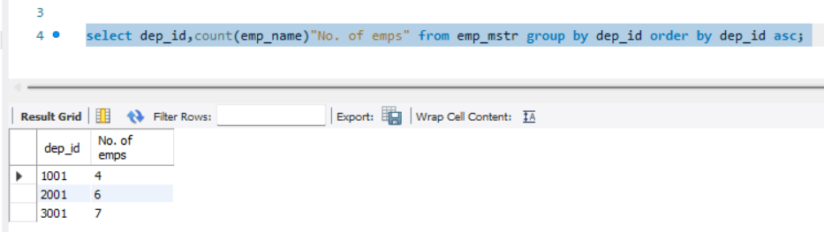

1. Find out total number of job role assigned in each department.

>select dep_id,count(job_name)"No. of Jobs roles" from emp_mstr group by dep_id order by dep_id asc;

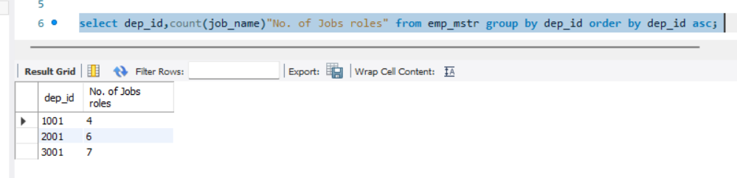

1. Find out employee’s names and salary whose having salary more than 2000.

(Duplication in employee name should be removed)

select distinct emp_name,salary from emp_mstr where salary > 2000;

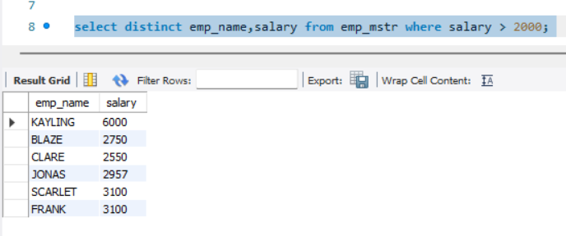

1. Find out number of employees hired after 03rd April 1991.

select distinct emp_name,hire_date from emp_mstr where date(hire_date) > '1991- 04-03';

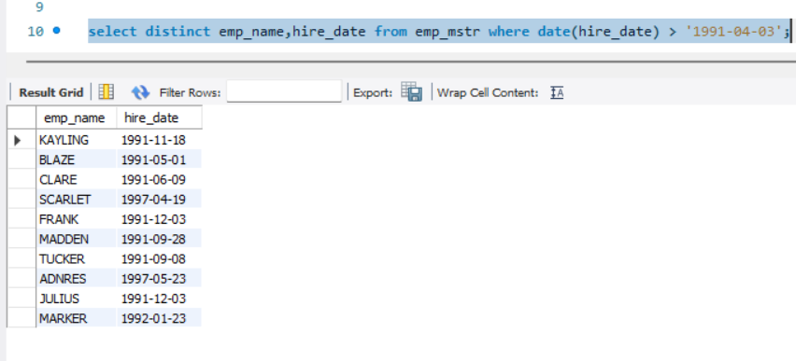

1. lists the number of employees in each job role, sorted high to low.

select job_name,count(emp_name) as no_of_emps from emp_mstr group by job_name order by no_of_emps;

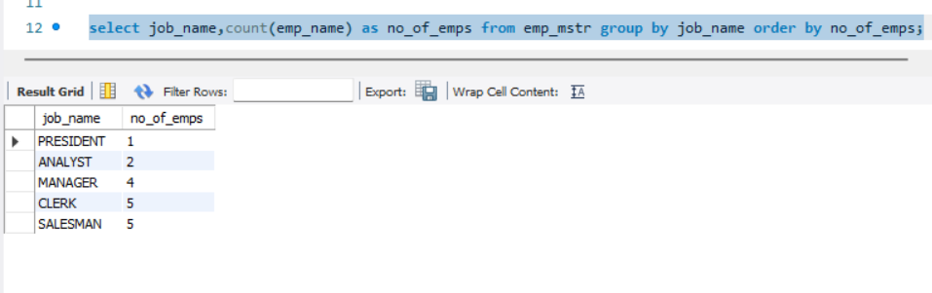

1. lists the number of employees in each department. Only include department with more than 3 employees in each.

select dep_id,count(emp_name) as no_of_emps from emp_mstr group by dep_id having no_of_emps>3 order by dep_id;

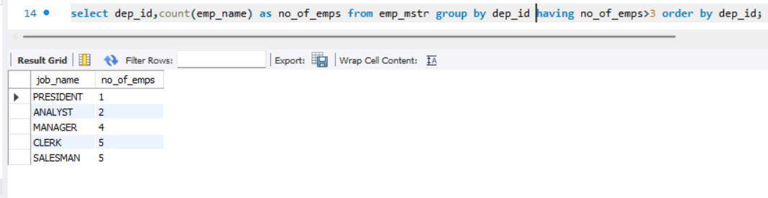

1. Display the total amount of the salary on each department.

select dep_id,sum(salary) from emp_mstr group by dep_id;

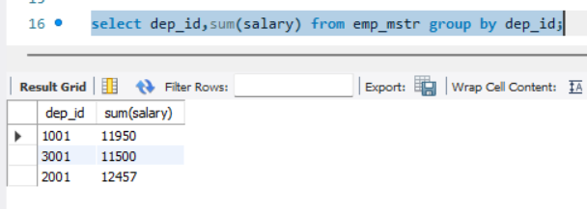

1. Count total number of employees assigned in each department whose name end with “n”.

SELECT dep_id,count(emp_id) FROM emp_mstr WHERE emp_name LIKE ("%n")group by dep_id;

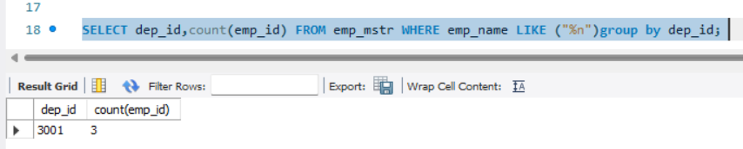

1. Find out total number of employees having "a" as a character in their name in each department.

SELECT dep_id,count(emp_id) FROM emp_mstr WHERE emp_name LIKE ("%a%")group by dep_id;

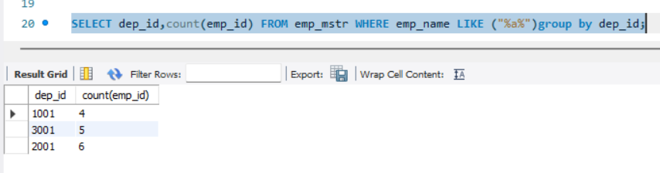

1. Find out total number of employees having salary more than average salary of all the employee in each department.

SELECT dep_id, COUNT(*) AS employee_count FROM emp_mstr e1 WHERE salary > (SELECT AVG(salary) FROM emp_mstr e2 WHERE e1.dep_id = e2.dep_id) GROUP BY dep_id;

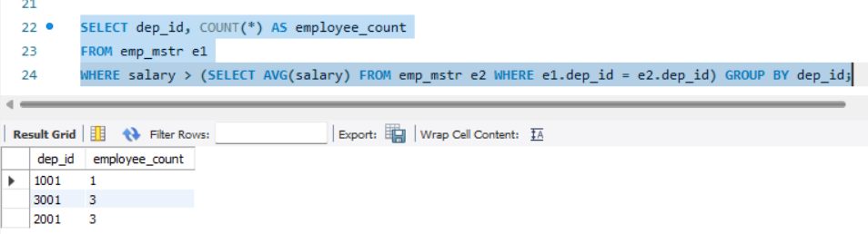

1. Display total number of employees in each department whose department having more than 2 employees also display department id in descending order.

select dep_id,count(emp_name) as no_of_emps from emp_mstr group by dep_id having no_of_emps>2 order by dep_id desc;

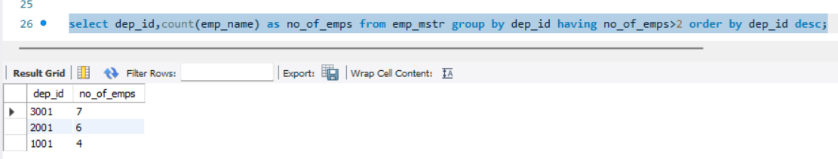

1. Display department wise average salary of employee.

SELECT dep_id,AVG(salary) AS avg_salary FROM emp_mstr GROUP BY dep_id;



1. Display department id of the employee along with salary whose salary is maximum in respective department.

SELECT dep_id,MAX(salary) FROM emp_mstr GROUP BY dep_id;

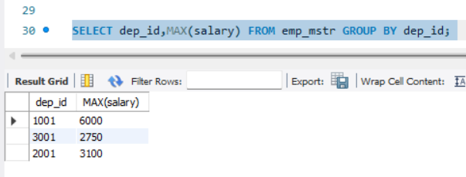



1. Display department id of the employee along with salary whose salary is minimum in respective department.

SELECT dep_id,MIN(salary) FROM emp_mstr GROUP BY dep_id

